Screenshots Portfolio Critical Thinking Module 3
Landing Page
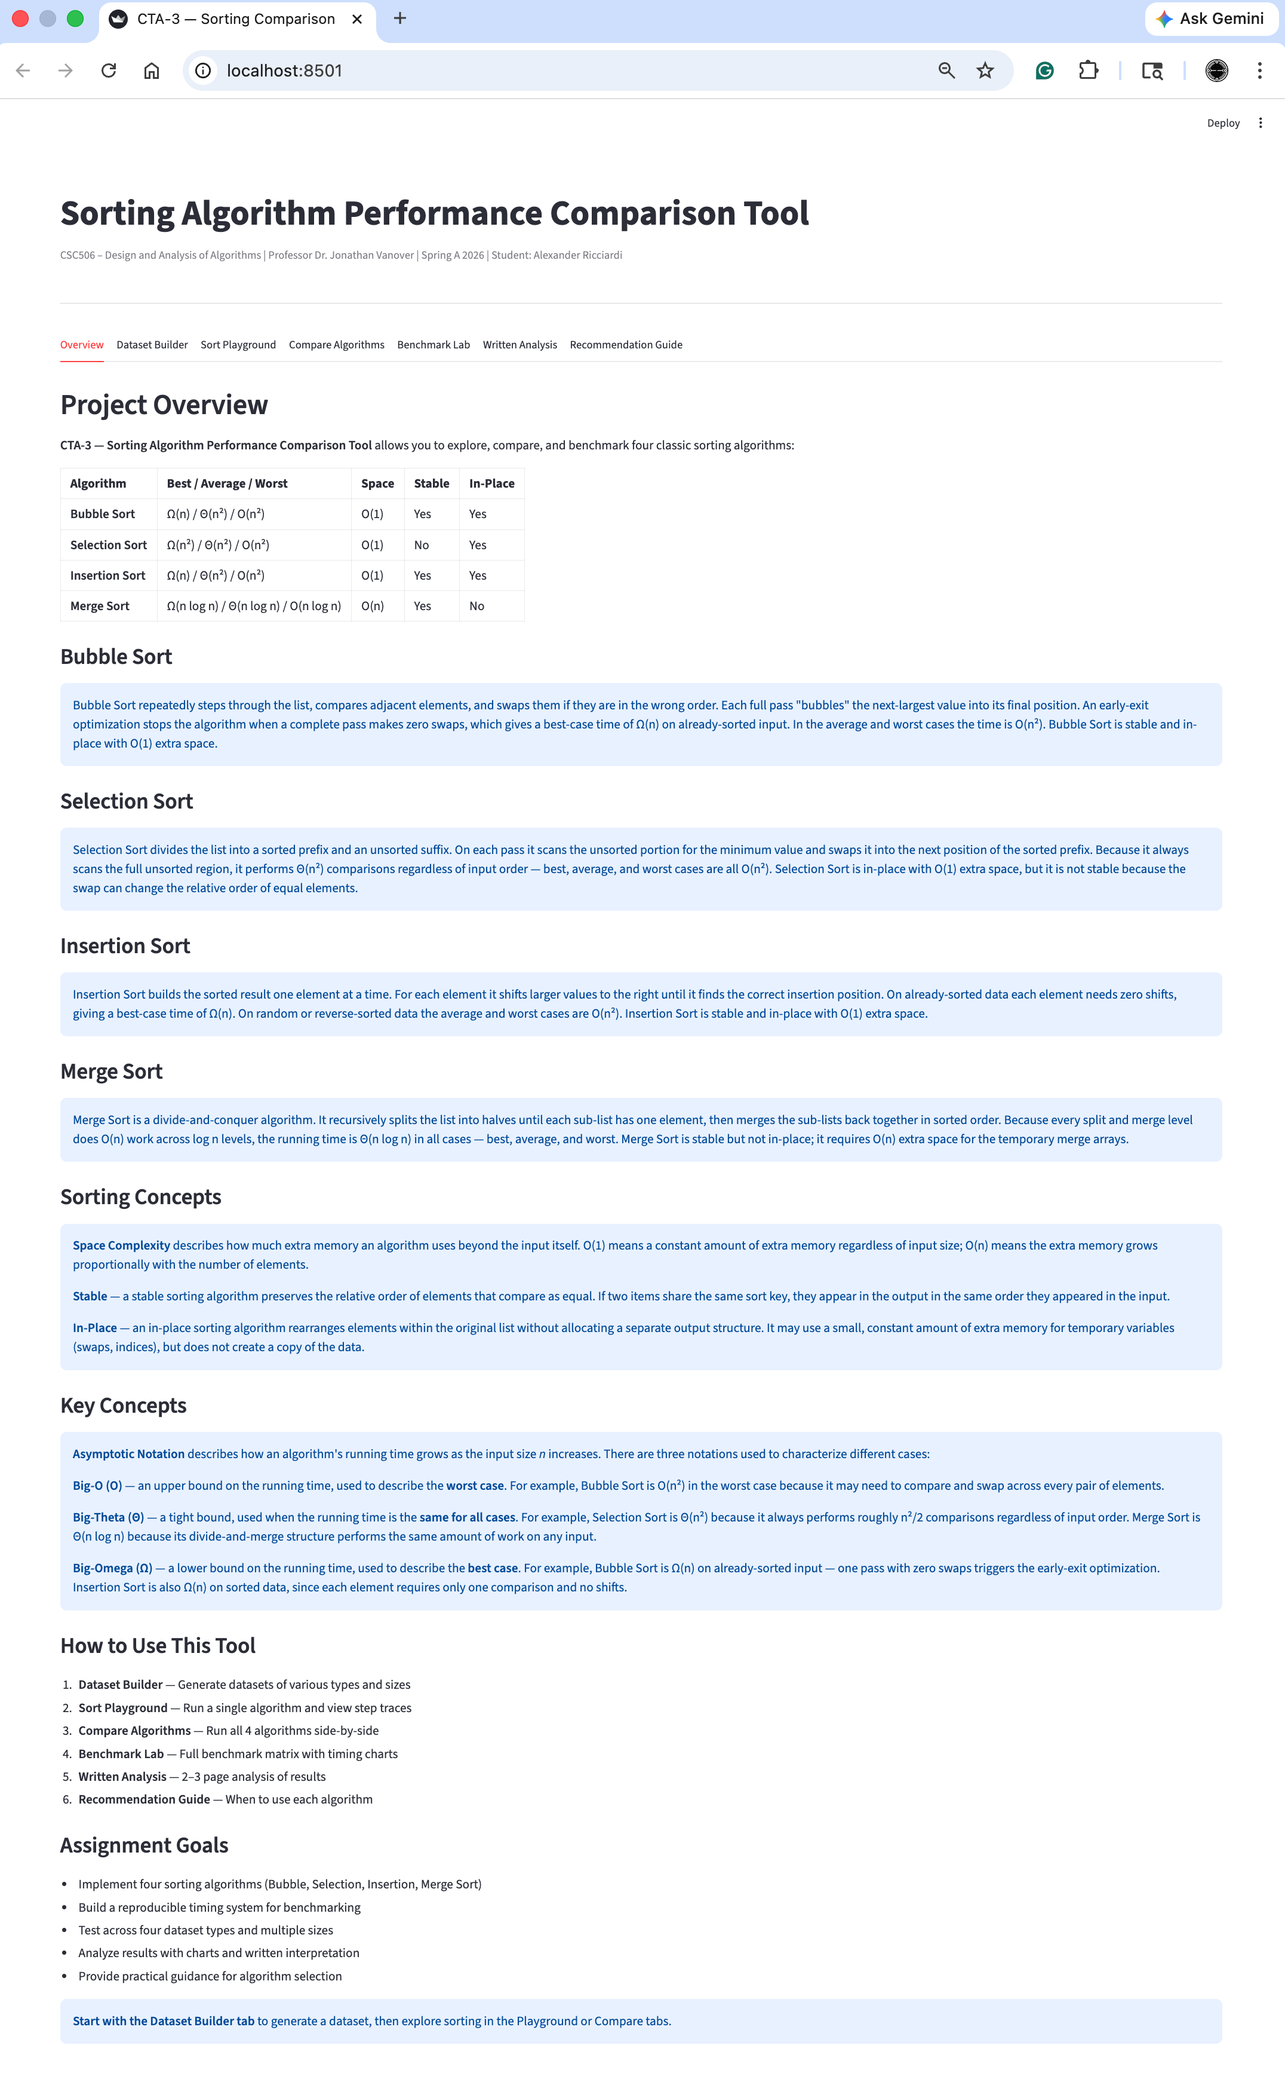
Dataset Builder
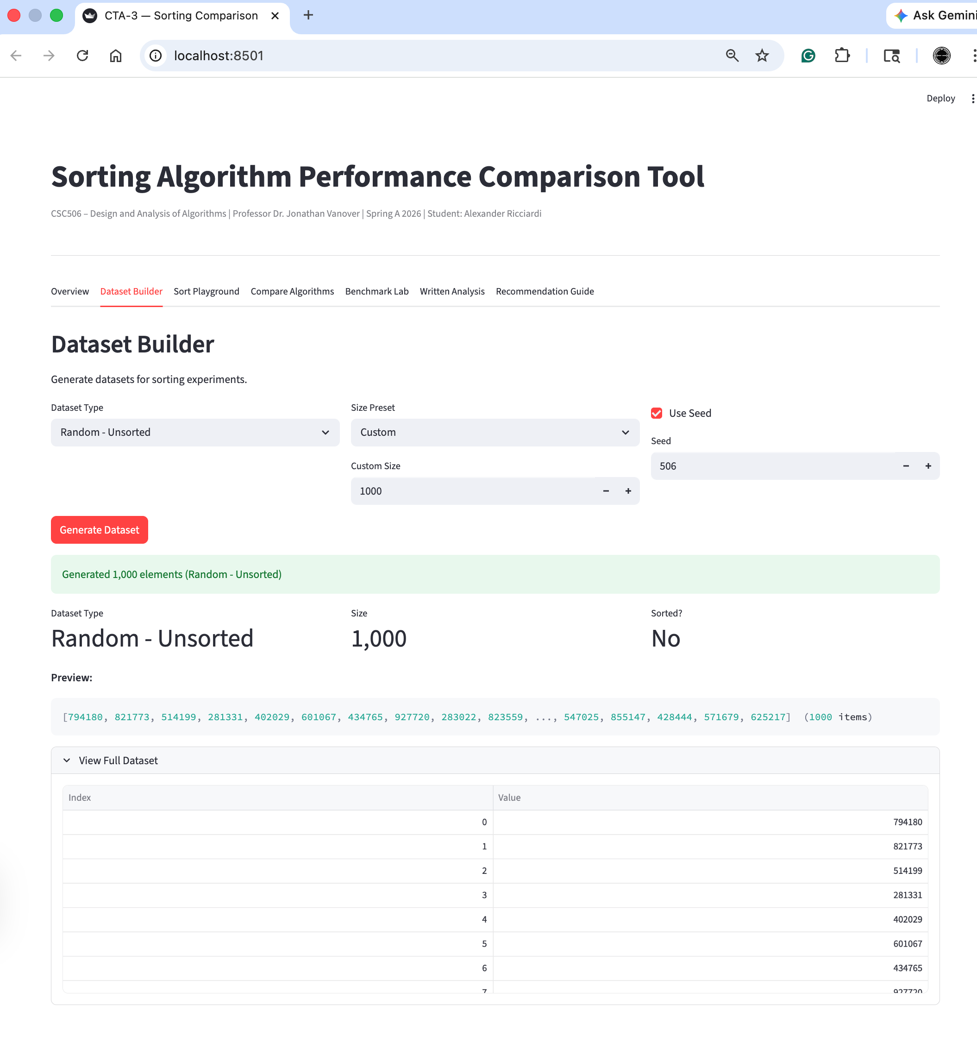

Sort Playground (Bubble Sort)
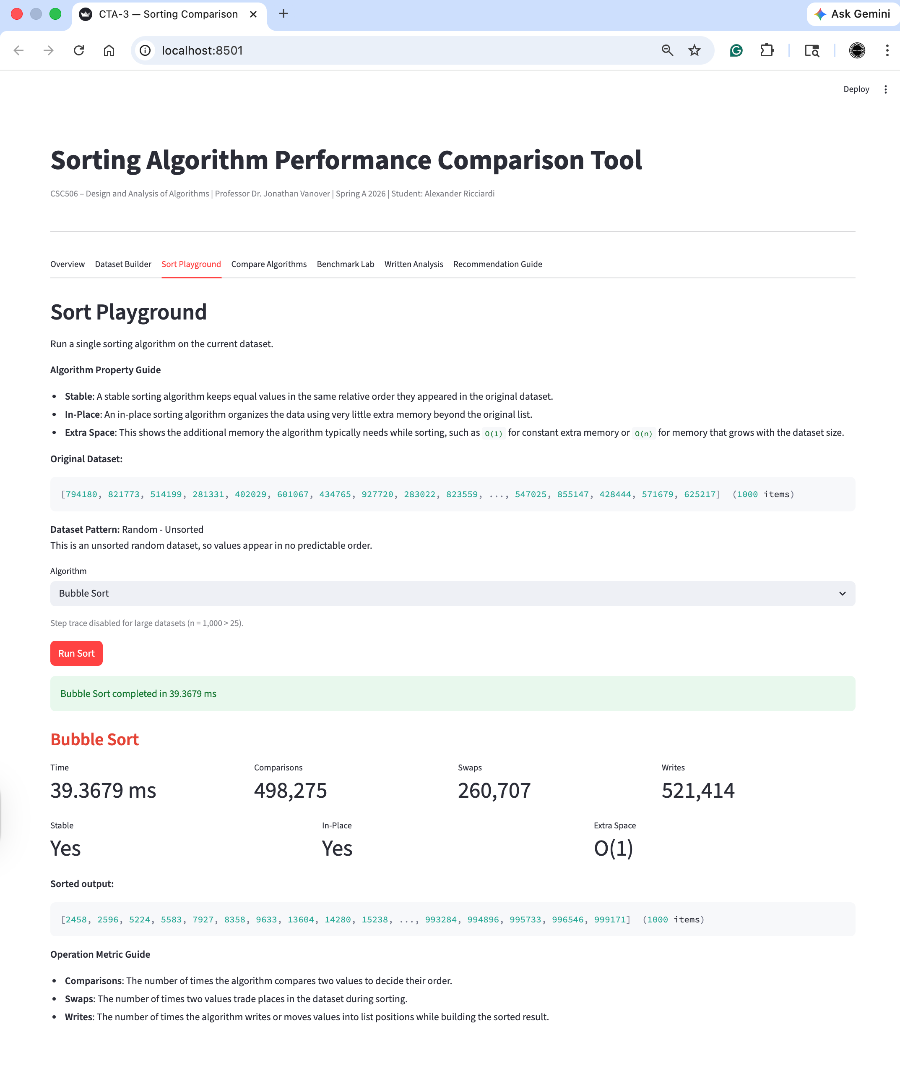

Sort Playground (Selection Sort)
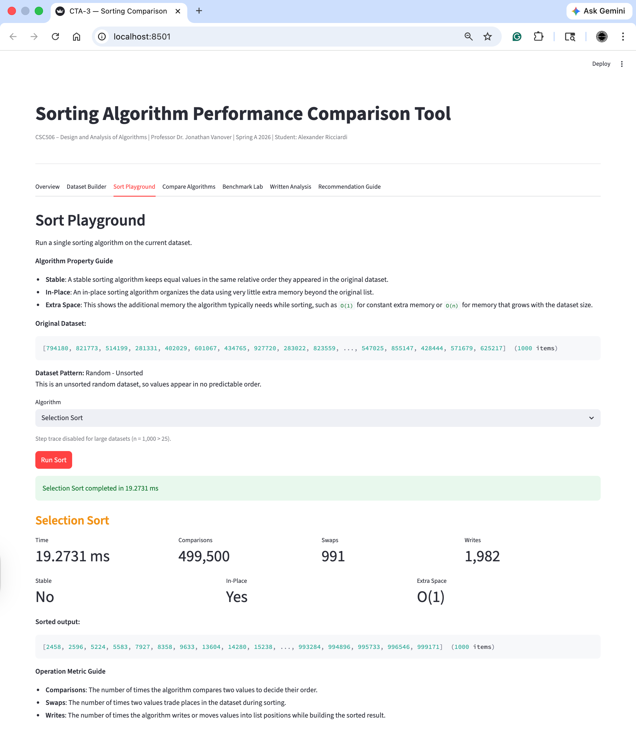

Sort Playground (Insertion Sort)
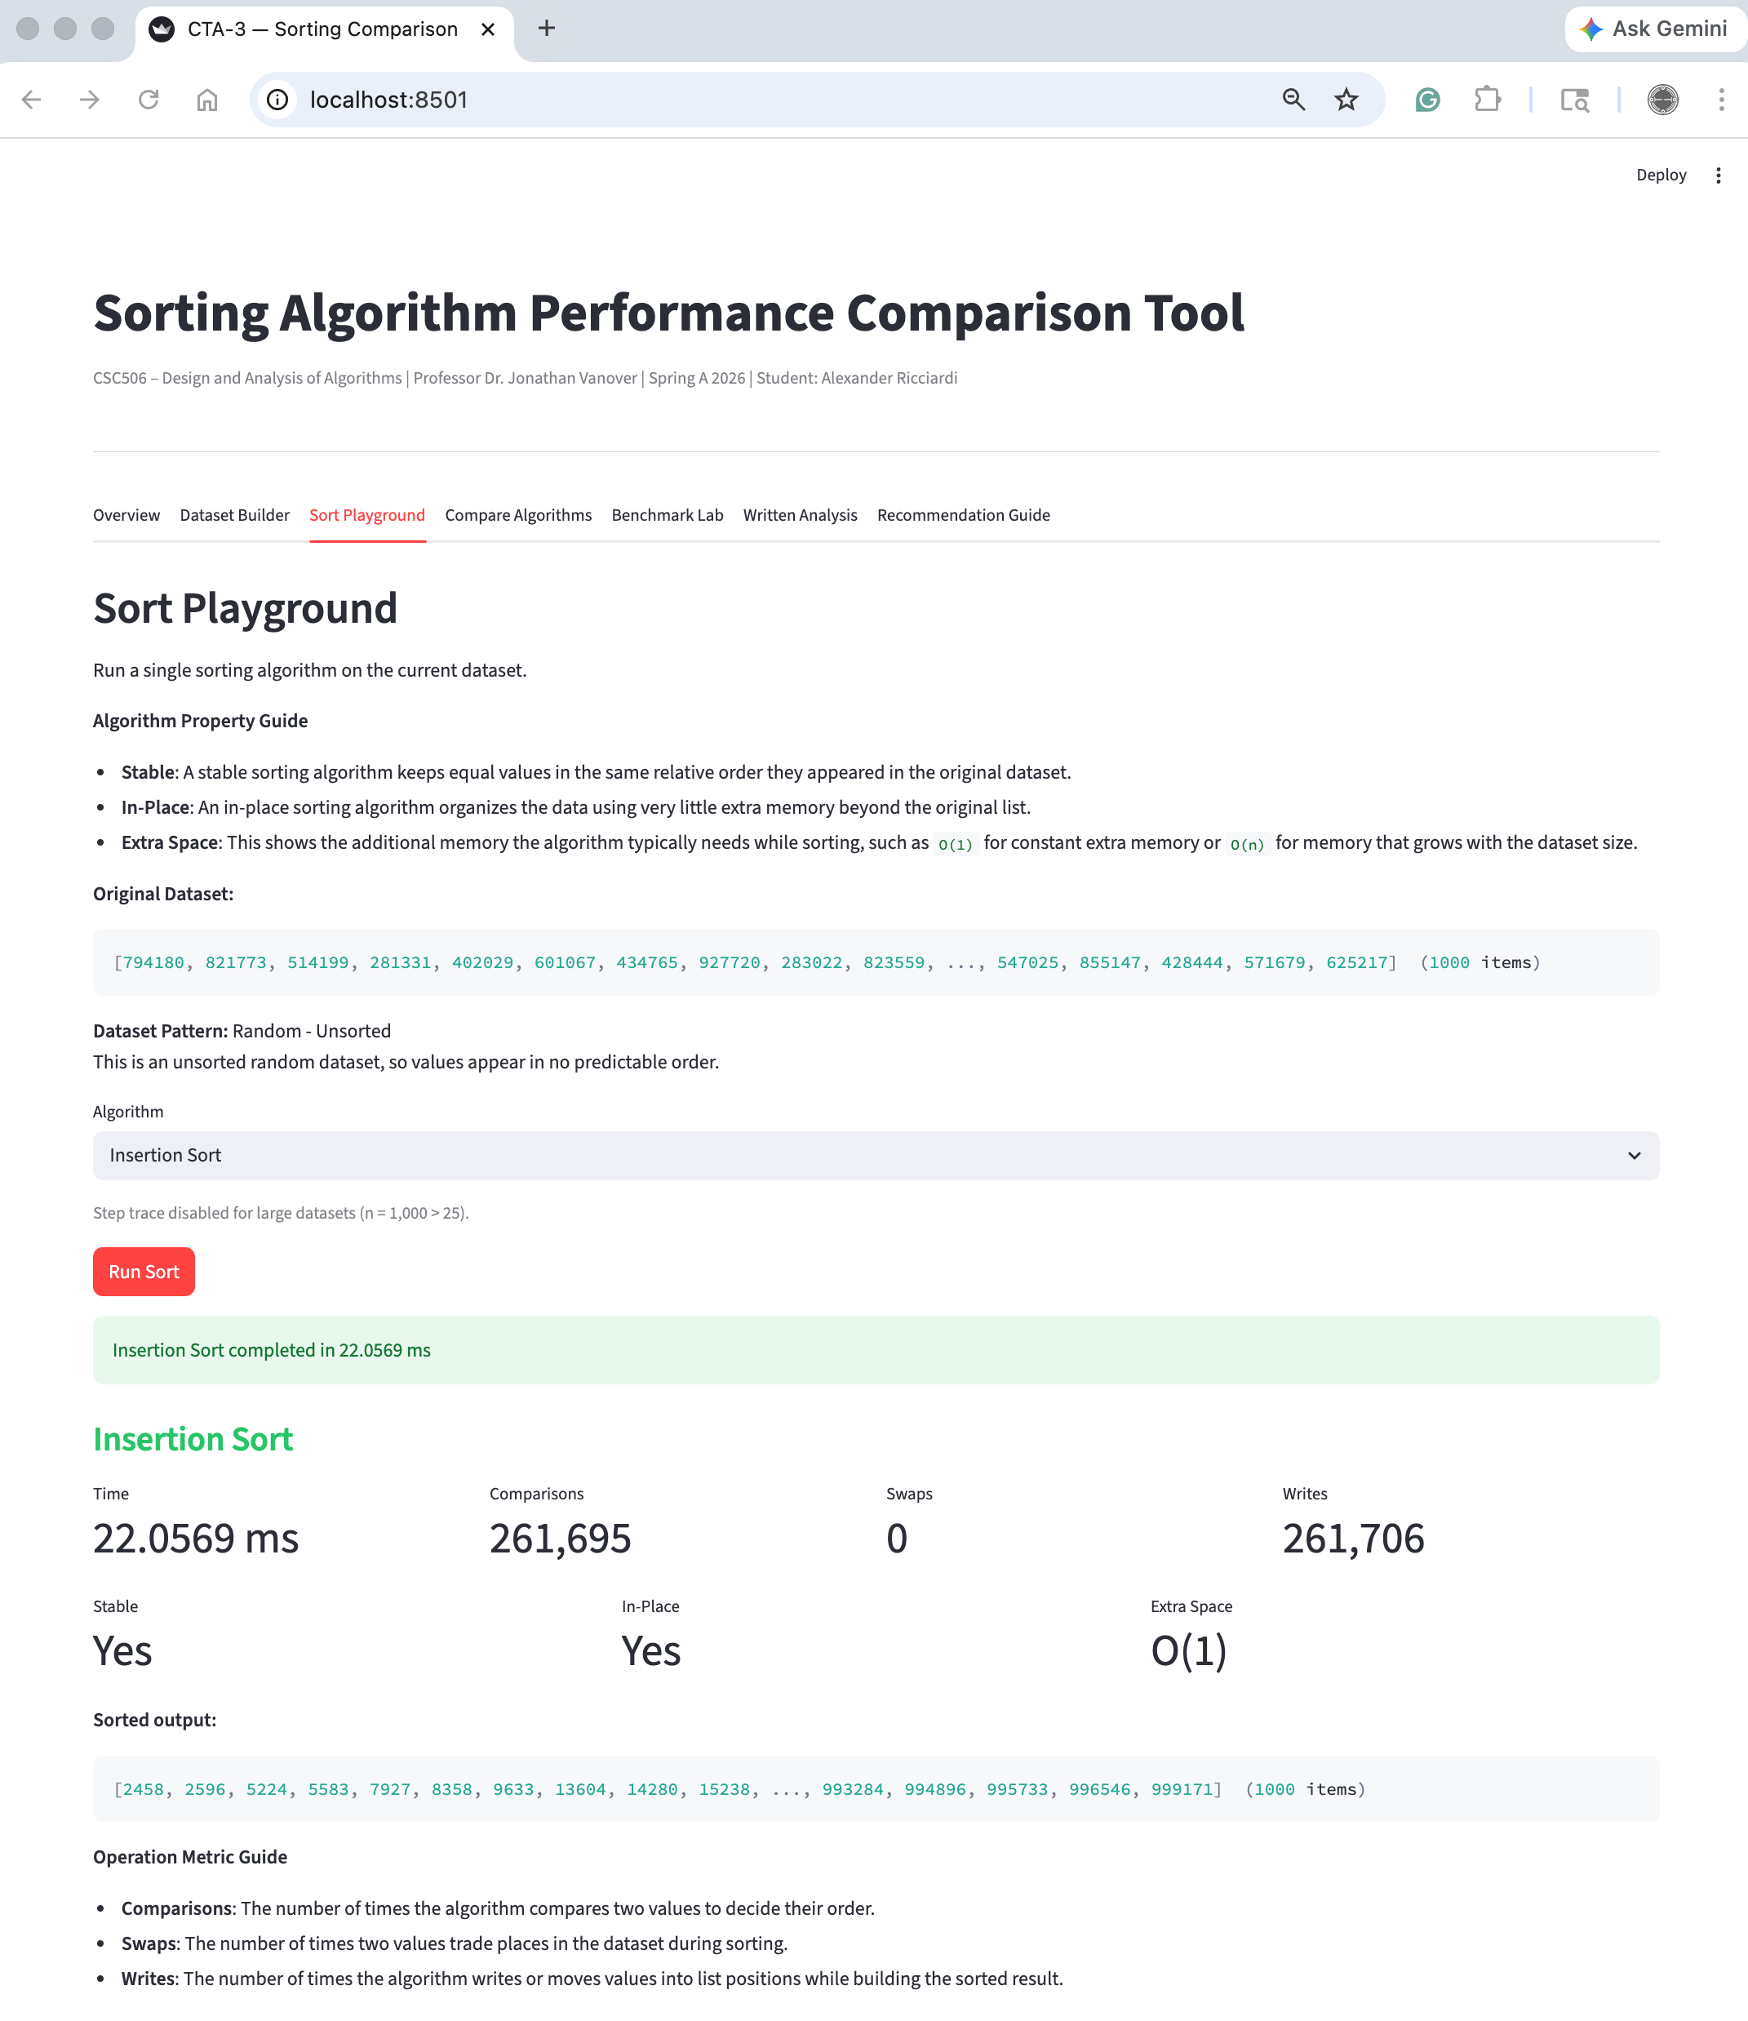

Sort Playground (Merge Sort)
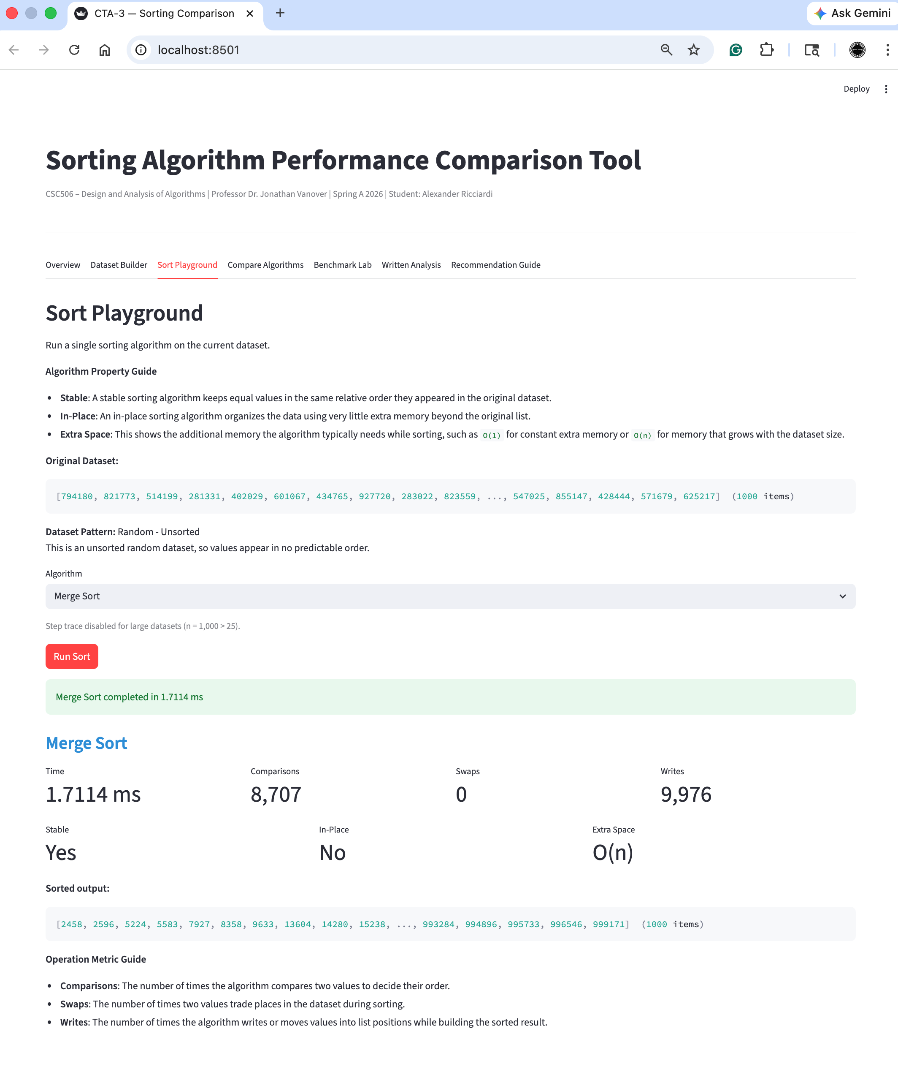
Compare Algorithms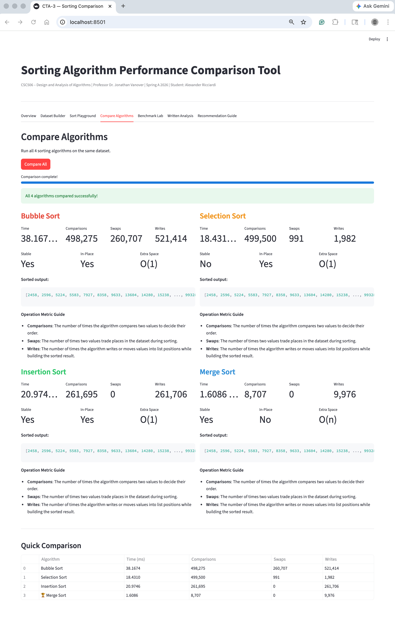
Benchmark Lab
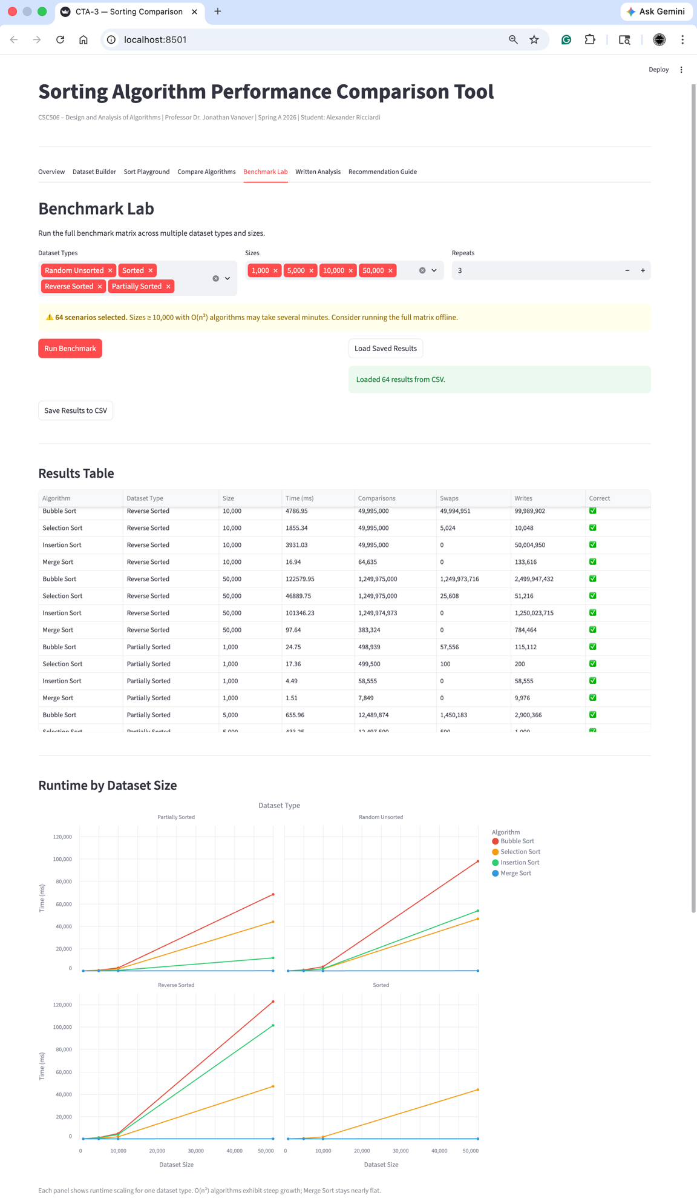

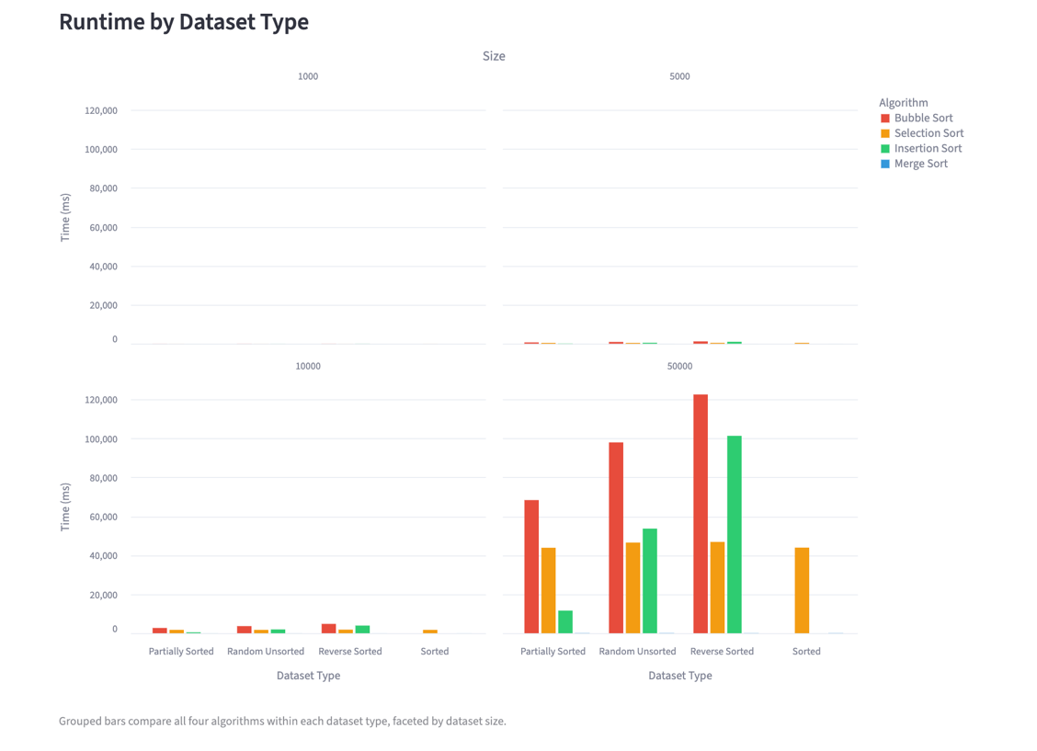

See next page

Written Analysis (see the provided Word Doc for the full text)

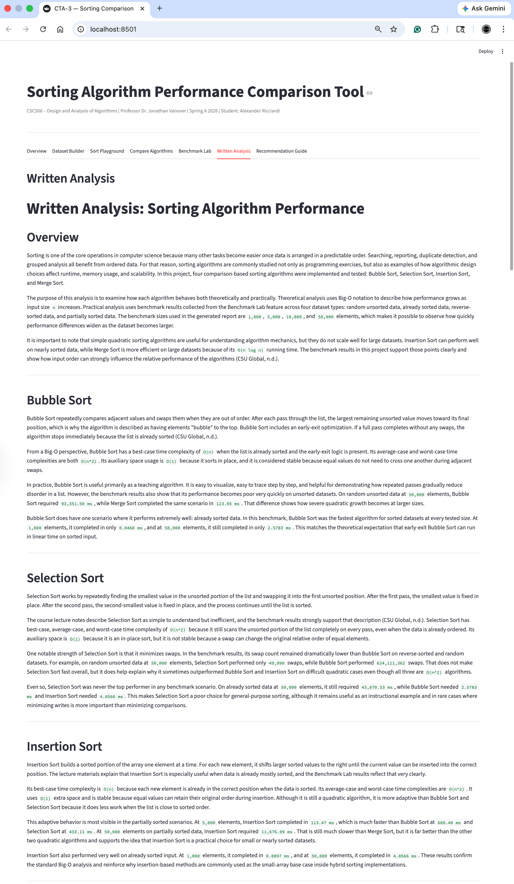
Recommendation Guide (see the provided Word Doc for the full text)
